Федеральное государственное бюджетное образовательное учреждение

высшего образования

«Российский экономический университет им. Г.В. Плеханова»

Московский приборостроительный техникум

Специальность: 09.02.07 Информационные системы и программирование

Квалификация: Программист

Общепрофессиональная дисциплина: ОП 08 Основы проектирования баз данных

МПТ.09.02.07-П.ОП.08.ОПБД.П50-7-20.10.22

Отчёт к практической работе № 5

«Реализация таблиц и ограничений в базе данных»

Тема: «Разработка базы данных на примере предметной области: ««Ресторан». Реализация

подсистем: учёт и обработка заказов, учёт и реализация меню».

|  |  |
| --- | --- |
| Проверил: | Выполнил: |
| Щаников И.М.__________ | Студент группы |
| (________)_____________ | П50-7-20 |
| «___»_____________2022г. | ____________Огурцов А.А. |
|  | «___»_____________2022г. |

2022

СОДЕРЖАНИЕ

1. ЦЕЛИ ПРАКТИЧЕСКОЙ РАБОТЫ 3

2. ЭТАПЫ ВЫПОЛНЕНИЯ 4

3. ВЫВОД 5

4. СПИСОК ИСПОЛЬЗУЕМЫХ МАТЕРИАЛОВ 6

1. ЦЕЛИ ПРАКТИЧЕСКОЙ РАБОТЫ

На основании даталогической модели данных и словаря данных, разработать структуру таблиц базы данных, на сервере СУБД.

ЭТАПЫ ВЫПОЛНЕНИЯ

1. Проект даталогической модели данных, на основании 4 практической работы;

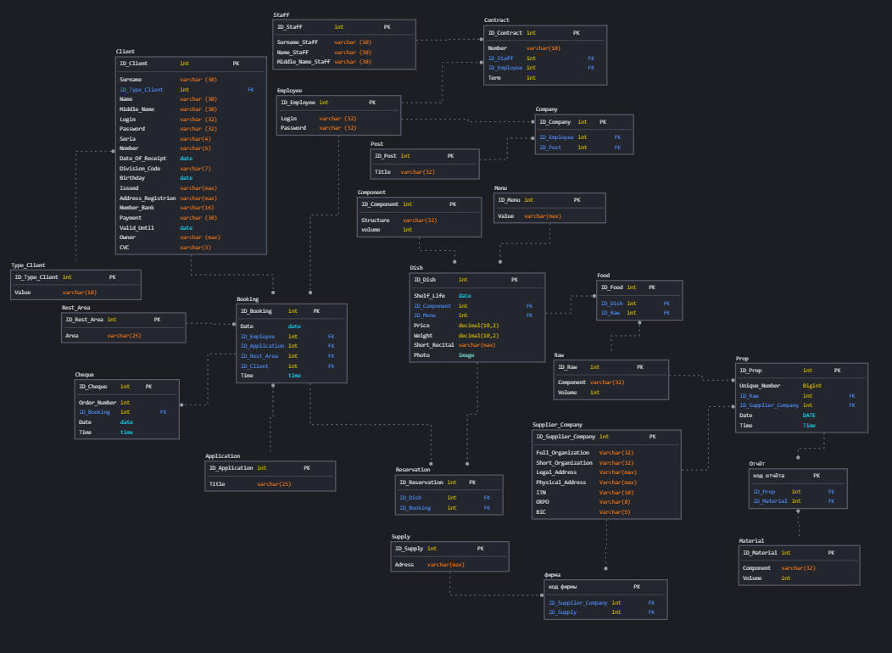

1. Реализация скрипта настройки и создания файла базы данных;

|  |  |
| --- | --- |
| Название объекта | Скрипт объекта |
| Restoran_DB | set ansi_nulls on  go  set ansi_padding on  go  set quoted_identifier on  go  create database [Restoran_DB]  go  use [Restoran_DB]  go |

1. На основании словаря данных, произвести реализацию родительских таблиц базы данных (Поле с типом данных, Varchar (max), не может быть с ограничением unique – пометить жёлтым цветом);

|  |  |  |  |  |
| --- | --- | --- | --- | --- |
| Ключ | Наименование | Тип данных | Примечание | Скрипт объекта |
| Type_Client | | | | |
| PK | ID_Type_Client | INT | Первичный ключ таблицы “Тип клиента” | create table [dbo].[Type_Client]  (  [ID_Type_Client] [int] not null identity(1,1),  [Value] [varchar] (10) not null  constraint [PK_Type_Client] primary key clustered  ([ID_Type_Client] ASC) on [PRIMARY],  constraint [UQ_Value_Type_Client] unique ([Value])  )  go |
|  | Value | VARCHAR (10) | Уникальное поле |
| Post | | | | |
| PK | ID_Post | INT | Первичный ключ таблицы “Должность” | create table [dbo].[Post]  (  [ID_Post] [int] not null identity(1,1),  [Title] [varchar] (32) not null  constraint [PK_Post] primary key clustered  ([ID_Post] ASC) on [PRIMARY],  constraint [UQ_Title_Post] unique ([Title])  )  go |
|  | Title | VARCHAR (32) | Уникальное поле |
| Menu | | | | |
| PK | ID_Menu | INT | Первичный ключ таблицы “Меню” | create table [dbo].[Menu]  (  [ID_Menu] [int] not null identity(1,1),  [Value] [varchar] (max) not null  constraint [PK_Menu] primary key clustered  ([ID_Menu] ASC) on [PRIMARY]  )  go |
|  | Value | VARCHAR (MAX) | Уникальное поле |
| Component | | | | |
| PK | ID_Component | INT | Первичный ключ таблицы “Ингредиенты” | create table [dbo].[Component]  (  [ID_Component] [int] not null identity(1,1),  [Structure] [varchar] (32) not null,  [Volume] [int] not null  constraint [PK_Component] primary key clustered  ([ID_Component] ASC) on [PRIMARY],  constraint [UQ_Structure_Component] unique ([Structure]),  constraint [CH_Volume_Component] check ([Volume] > 0)  )  go |
|  | Structure | VARCHAR (32) | Уникальное поле |
|  | Volume | INT | Проверка на отрицательность |
| Supply | | | | |
| PK | ID_ Supply | INT | Первичный ключ таблицы “Поставка” | create table [dbo].[Supply]  (  [ID_Supply] [int] not null identity(1,1),  [Adress] [varchar] (max) not null  constraint [PK_Supply] primary key clustered  ([ID_Supply] ASC) on [PRIMARY]  )  go |
|  | Adress | VARCHAR (MAX) | Уникальное поле |
| Raw | | | | |
| PK | ID_Raw | INT | Первичный ключ таблицы “Сырьё” | create table [dbo].[Raw]  (  [ID_Raw] [int] not null identity(1,1),  [Component] [varchar] (32) not null,  [Volume] [int] not null  constraint [PK_Raw] primary key clustered  ([ID_Raw] ASC) on [PRIMARY],  constraint [UQ_Component_Raw] unique ([Component]),  constraint [CH_Volume_Raw] check ([Volume] > 0)  )  go |
|  | Component | VARCHAR(32) | Уникальное поле |
|  | Volume | INT | Проверка на отрицательность |
| Material | | | | |
| PK | ID_Material | INT | Первичный ключ таблицы “Материал” | create table [dbo].[Material]  (  [ID_Material] [int] not null identity(1,1),  [Component] [varchar] (32) not null,  [Volume] [int] not null  constraint [PK_Material] primary key clustered  ([ID_Material] ASC) on [PRIMARY],  constraint [UQ_Component_Material] unique ([Component]),  constraint [CH_Volume_Material] check ([Volume] > 0)  )  go |
|  | Component | VARCHAR (32) | Уникальное поле |
|  | Volume | INT | Проверка на отрицательность |
| Application | | | | |
| PK | ID_Application | INT | Первичный ключ таблицы “Заявка” | create table [dbo].[Application]  (  [ID_Application] [int] not null identity(1,1),  [Title] [varchar] (25) not null  constraint [PK_Application] primary key clustered  ([ID_Application] ASC) on [PRIMARY],  constraint [UQ_Title_Application] unique ([Title])  )  go |
|  | Title | VARCHAR (25) | Уникальное поле |
| Employee | | | | |
| PK | ID_Employee | INT | Первичный ключ таблицы “Сотрудник” | create table [dbo].[Employee]  (  [ID_Employee] [int] not null identity(1,1),  [Login] [varchar] (32) not null,  [Password] [varchar] (32) not null  constraint [PK_Employee] primary key clustered  ([ID_Employee] ASC) on [PRIMARY],  constraint [UQ_Login_Employee] unique ([Login]),  constraint [CH_Login_Employee] check (len([Login])>=8),  constraint [CH_Password_Employee_Upper] check ([Password] like ('%[A-Z]%')),  constraint [CH_Password_Employee_Letter_Lower] check ([Password] like ('%[a-z]%')),  constraint [CH_Password_Employee_Symbols] check ([Password] like ('%[!@#$%^&*()]%'))  )  go |
|  | Login | VARCHAR (32) | Не менее 8 символов, уникальное поле |
|  | Password | VARCHAR (32) | Спец символы, минимум одна заглавная одна прописная латинская буквы |
| Staff | | | | |
| PK | ID_Staff | INT | Первичный ключ таблицы “Персонал” | create table [dbo].[Staff]  (  [ID_Staff] [int] not null identity(1,1),  [Name_Staff] [varchar] (30) not null,  [Surname_Staff] [varchar] (30) not null,  [Middle_Name_Staff] [varchar] (30) not null  constraint [PK_Staff] primary key clustered  ([ID_Staff] ASC) on [PRIMARY]  )  go |
|  | Name_Staff | VARCHAR (30) |  |
|  | Surname_Staff | VARCHAR (30) |  |
|  | Middle_Name_Staff | VARCHAR (30) |  |
| Rest_Area | | | | |
| PK | ID_Rest_Area | INT | Первичный ключ таблицы “Зона отдыха” | create table [dbo].[Rest_Area]  (  [ID_Rest_Area] [int] not null identity(1,1),  [Area] [varchar] (30) not null  constraint [PK_Rest_Area] primary key clustered  ([ID_Rest_Area] ASC) on [PRIMARY],  constraint [UQ_Area_Rest_Area] unique ([Area])  )  go |
|  | Area | VARCHAR (25) | Уникальное поле |
| Supplier_Company | | | | |
| PK | ID_Supplier_Company | INT | Первичный ключ таблицы “Фирма поставщика” | create table [dbo].[Supplier_Company]  (  [ID_Supplier_Company] [int] not null identity(1,1),  [Full_Organization] [varchar] (32) not null,  [Short_Organization] [varchar] (32) not null,  [Legal_Address] [varchar] (max) not null,  [Physical_Address] [varchar] (max) not null,  [ITN] [varchar] (10) not null,  [OKPO] [varchar] (8) not null,  [BIC] [varchar] (9) not null  constraint [PK_Supplier_Company] primary key clustered  ([ID_Supplier_Company] ASC) on [PRIMARY],  constraint [UQ_Full_Organization_Supplier_Company] unique ([Full_Organization]),  constraint [CH_ITN_Supplier_Company] check ([ITN] = 10),  constraint [CH_OKPO_Supplier_Company] check ([OKPO] = 8),  constraint [CH_BIC_Supplier_Company] check ([BIC] = 9)  )  Go |
|  | Full_Organization | VARCHAR (32) | Уникальное поле |
|  | Short_Organization | VARCHAR (32) |  |
|  | Legal_Address | VARCHAR (MAX) | Уникальное поле |
|  | Physical_Address | VARCHAR (MAX) | Уникальное поле |
|  | ITN | VARCHAR (10) | 10 цифр, Уникальное поле, Проверка на отрицательность |
|  | OKPO | VARCHAR (8) | 8 цифр, Уникальное поле, Проверка на отрицательность |
|  | BIC | VARCHAR (9) | 9 цифр, Уникальное поле, Проверка на отрицательность |

|  |  |  |  |  |
| --- | --- | --- | --- | --- |
| Client | | | | |
| PK | ID_Client | INT | Первичный ключ таблицы “Клиент” | create table [dbo].[Client]  (  [ID_Client] [int] not null identity(1,1),  [Type_Client_ID] [INT] not null,  [Name] [VARCHAR] (30) not null,  [Surname] [VARCHAR] (30) not null,  [Middle_Name] [VARCHAR] (30) not null,  [Seria] [VARCHAR] (4) not null,  [Nomber] [VARCHAR] (6) not null,  [Date_Of_Receipt] [DATE] null default(getdate()),  [Division_Code] [VARCHAR] (7) not null,  [Birthday] [DATE] null default(getdate()),  [Issued] [VARCHAR] (MAX) not null,  [Address_Registrion] [VARCHAR] (MAX) not null,  [Number_Bank] [VARCHAR] (16) not null,  [Payment] [VARCHAR] (30) not null,  [Valid_Until] [DATE] null default(getdate()),  [Owner] [VARCHAR] (MAX) not null,  [CVC] [VARCHAR] (3) not null,  [Login] [VARCHAR] (32) not null,  [Password] [VARCHAR] (32) not null  constraint [PK_Client] primary key clustered  ([ID_Client] ASC) on [PRIMARY],  constraint [UQ_Login_Client] unique ([Login]),  constraint [UQ_Number_Bank_Client] unique ([Number_Bank]),  constraint [CH_Login_Client] check (len([Login])>=8),  constraint [CH_Password_Client_Upper] check ([Password] like ('%[A-Z]%')),  constraint [CH_Password_Client_Letter_Lower] check ([Password] like ('%[a-z]%')),  constraint [CH_Password_Client_Symbols] check ([Password] like ('%[!@#$%^&*()]%')),  constraint [CH_CVC_Client] check ([CVC] = 3),  constraint [CH_CVC_Client_INT] check ([CVC] like '[0-9][0-9][0-9]'),  constraint [CH_Number_Bank_Client] check ([Number_Bank] = 16),  constraint [CH_Number_Bank_Client_INT] check ([Number_Bank] like '[0-9][0-9][0-9][0-9][0-9][0-9][0-9][0-9][0-9][0-9][0-9][0-9][0-9][0-9][0-9][0-9]'),  constraint [CH_Seria_Client] check ([Seria] = 4),  constraint [CH_Seria_Client_INT] check ([Seria] like '[0-9][0-9][0-9][0-9]'),  constraint [CH_Division_Code_Client] check ([Division_Code] like '[0-9][0-9][0-9][-][0-9][0-9][0-9]'),  constraint [CH_Nomber_Client] check ([Nomber] = 5),  constraint [CH_Nomber_Client_INT] check ([Nomber] like '[0-9][0-9][0-9][0-9][0-9][0-9]'),  constraint [FK_Type_Client] foreign key ([Type_Client_ID]) references [dbo].[Type_Client] ([ID_Type_Client]),  constraint [UQ_Seria_Nomber_Client] unique ([Nomber], [Seria]),  constraint [CH_Birthday_Client] check ([Birthday] < getdate()),  constraint [CH_Date_Of_Receipt_Client] check ([Date_Of_Receipt] > getdate())  )  go |
| FK | Type_Client_ID | INT |  |
|  | Name | VARCHAR (30) |  |
|  | Surname | VARCHAR (30) |  |
|  | Middle_Name | VARCHAR (30) |  |
|  | Seria | VARCHAR (4) | 4 цифры, Проверка на отрецательность |
|  | Nomber | VARCHAR (6) | 6 цифр, Проверка на отрецательность |
|  | Date_Of_Receipt | DATE | 31-12-2000, Дата>дня рождения |
|  | Division_Code | VARCHAR (7) | ###-### |
|  | Birthday | DATE | 31-12-2000, Дата<Текущей даты |
|  | Issued | VARCHAR (MAX) |  |
|  | Address_Registrion | VARCHAR (MAX) |  |
|  | Number_Bank | VARCHAR (16) | 16 цифр, Уникальное поле, Проверка на отрецательность |
|  | Payment | VARCHAR (30) |  |
|  | Valid_Until | DATE | 31-12-2000, Дата<=Текущей даты |
|  | Owner | VARCHAR (MAX) |  |
|  | CVC | VARCHAR (3) | 3 цифры, Проверка на отрицательность |
|  | Login | VARCHAR (32) | Не менее 8 символов, уникальное поле |
|  | Password | VARCHAR (32) | Спец символы, минимум одна заглавная одна прописная латинская буквы |
| Dish | | | | |
| PK | ID_Dish | INT | Первичный ключ таблицы “Блюдо” | create table [dbo].[Dish]  (  [ID_Dish] [int] not null identity(1,1),  [Component_ID] [int] not null,  [Menu_ID] [int] not null,  [Shelf_Life] [date] default (format(Getdate(),'dd-MM-yyyy')),  [Photo] [image] not null,  [Price] [int] not null,  [Weight] [int] not null,  [Short_Recital] [varchar] (max) not null  constraint [PK_Dish] primary key clustered  ([ID_Dish] ASC) on [PRIMARY],  constraint [FK_Component] foreign key ([Component_ID])  references [dbo].[Component] ([ID_Component]),  constraint [FK_Menu] foreign key ([Menu_ID])  references [dbo].[Menu] ([ID_Menu]),  )  go |
| FK | Component_ID | INT |  |
| FK | Menu_ID | INT |  |
|  | Shelf_Life | DATE | 31-12-2000, Дата>=Текущей дате |
|  | Photo | IMAGE | Уникальное поле |
|  | Price | DECIMAL(10,2) | Не отрицательное |
|  | Weight | DECIMAL(10,2) | Не отрицательное |
|  | Short_Recital | VARCHAR (MAX) | Уникальное поле |
| Booking | | | | |
| PK | ID_Booking | INT | Первичный ключ таблицы “Бронирование” | create table [dbo].[Booking]  (  [ID_Booking] [int] not null identity(1,1),  [Employee_ID] [int] not null,  [Application_ID] [int] not null,  [Rest_Area_ID] [int] not null,  [Client_ID] [int] not null,  [Date] [date] not null,  [Time] [time] not null  constraint [PK_Booking] primary key clustered  ([ID_Booking] ASC) on [PRIMARY],  constraint [FK_Employee_Booking] foreign key ([Employee_ID])  references [dbo].[Employee] ([ID_Employee]),  constraint [FK_Application_Booking] foreign key ([Application_ID])  references [dbo].[Application] ([ID_Application]),  constraint [FK_Rest_Area_Booking] foreign key ([Rest_Area_ID])  references [dbo].[Rest_Area] ([ID_Rest_Area]),  constraint [FK_Client_Booking] foreign key ([Client_ID])  references [dbo].[Client] ([ID_Client]),  constraint [CH_Date_Booking] check ([Date] > getdate()),  constraint [CH_Time_Booking] check ([Time] > Convert(time, SYSDATETIME()))  )  go |
| FK | Employee_ID | INT |  |
| FK | Application_ID | INT |  |
| FK | Rest_Area_ID | INT |  |
| FK | ID_Client | INT |  |
|  | Date | DATE | 31-12-2000, Дата>=Текущей дате |
|  | Time | TIME | 24:33, Время>=Текущему времени |
| Cheque | | | | |
| PK | ID_Cheque | INT | Первичный ключ таблицы “Чек” | create table [dbo].[Cheque]  (  [ID_Cheque] [int] not null identity(1,1),  [Booking_ID] [int] not null,  [Order_Number] [int] not null,  [Date] [date] null default(getdate()),  [Time] [time] null default(Convert(time, SYSDATETIME()))  constraint [PK_Cheque] primary key clustered  ([ID_Cheque] ASC) on [PRIMARY],  constraint [FK_Booking_Cheque] foreign key ([Booking_ID])  references [dbo].[Booking] ([ID_Booking])  )  go |
| FK | Booking_ID | INT |  |
|  | Order_Number | INT | Уникальное поле |
|  | Date | DATE | 31-12-2000, Дата=Текущей дате |
|  | Time | TIME | 24:33, Время=Текущему времени |
| Contract | | | | |
| PK | ID_Contract | INT | Первичный ключ таблицы “Контракт” | create table [dbo].[Contract]  (  [ID_Contract] [int] not null identity(1,1),  [Staff_ID] [int] not null,  [Employee_ID] [int] not null,  [Nomber] [VARCHAR] (10) not null,  [Term] [int] not null  constraint [PK_Contract] primary key clustered  ([ID_Contract] ASC) on [PRIMARY],  constraint [FK_Staff] foreign key ([Staff_ID])  references [dbo].[Staff] ([ID_Staff]),  constraint [FK_Employee_Contract] foreign key ([Employee_ID])  references [dbo].[Employee] ([ID_Employee]),  constraint [CH_Nomber_Contract] check ([Nomber] like '[0-9][0-9][0-9][0-9][0-9][0-9][0-9][0-9][0-9][0-9]'),  constraint [UQ_Nomber_Contract] unique ([Nomber]),  constraint [CH_Term_Contract] check ([Term] > 0)  )  go |
| FK | Staff_ID | INT |  |
| FK | Employee_ID | INT |  |
|  | Nomber | VARCHAR (10) | Уникальное поле, 10 цифр, Проверка на отрицательность |
|  | Term | INT | В месяцах, Проверка на отрицательность |
| Prop | | | | |
| PK | ID_Prop | INT | Первичный ключ таблицы “Реквизит” | create table [dbo].[Prop]  (  [ID_Prop] [int] not null identity(1,1),  [Raw_ID] [int] not null,  [Supplier_Company_ID] [int] not null,  [Unique_Number] [BIGINT] not null,  [Date] [date] null default(getdate()),  [Time] [time] null default(Convert(time, SYSDATETIME()))  constraint [PK_Prop] primary key clustered  ([ID_Prop] ASC) on [PRIMARY],  constraint [FK_Raw_Prop] foreign key ([Raw_ID])  references [dbo].[Raw] ([ID_Raw]),  constraint [FK_Supplier_Company_Prop] foreign key ([Supplier_Company_ID])  references [dbo].[Supplier_Company] ([ID_Supplier_Company]),  constraint [CH_Unique_Number_Prop] check ([Unique_Number] > 0)  )  go |
| FK | Raw_ID | INT |  |
| FK | Supplier_Company _ID | INT |  |
|  | Unique_Number | BIGINT | Уникальное поле, Проверка на отрицательность |
|  | Date | DATE | 31-12-2000, Дата=Текущей дате |
|  | Time | TIME | 24:33, Время=Текущему времени |
| Company | | | | |
| PK | ID_Compony | INT | Первичный ключ таблицы “Компания” | create table [dbo].[Company]  (  [ID_Compony] [int] not null identity(1,1),  [Employee_ID] [int] not null,  [Post_ID] [int] not null  constraint [PK_Company] primary key clustered  ([ID_Compony] ASC) on [PRIMARY],  constraint [FK_Post] foreign key ([Post_ID])  references [dbo].[Post] ([ID_Post]),  constraint [FK_Employee_Company] foreign key ([Employee_ID])  references [dbo].[Employee] ([ID_Employee]),  )  Go |
| FK | Employee_ID | INT |  |
| FK | Post_ID | INT |  |
| Reservation | | | | |
| PK | ID_Reservation | INT | Первичный ключ таблицы “Бронь” | create table [dbo].[Reservation]  (  [ID_Reservation] [int] not null identity(1,1),  [Booking_ID] [int] not null,  [Dish_ID] [int] not null  constraint [PK_Reservation] primary key clustered  ([ID_Reservation] ASC) on [PRIMARY],  constraint [FK_Booking_Reservation] foreign key ([Booking_ID])  references [dbo].[Booking] ([ID_Booking]),  constraint [FK_Dish_Reservation] foreign key ([Dish_ID])  references [dbo].[Dish] ([ID_Dish])  )  go |
| FK | Dish_ID | INT |  |
| FK | Booking_ID | INT |  |
| Firm | | | | |
| PK | ID_Firm | INT | Первичный ключ таблицы “Фирма” | create table [dbo].[Firm]  (  [ID_Firm] [int] not null identity(1,1),  [Supply_ID] [int] not null,  [Supplier_Company_ID] [int] not null  constraint [PK_Firm] primary key clustered  ([ID_Firm] ASC) on [PRIMARY],  constraint [FK_Supply_Firm] foreign key ([Supply_ID])  references [dbo].[Supply] ([ID_Supply]),  constraint [FK_Supplier_Company_Firm] foreign key ([Supplier_Company_ID])  references [dbo].[Supplier_Company] ([ID_Supplier_Company])  )  go |
| FK | Supplier_Company _ID | INT |  |
| FK | Supply_ID | INT |  |
| Report | | | | |
| PK | ID_Report | INT | Первичный ключ таблицы “Отчёт” | create table [dbo].[Report]  (  [ID_Report] [int] not null identity(1,1),  [Prop_ID] [int] not null,  [Material_ID] [int] not null  constraint [PK_Report] primary key clustered  ([ID_Report] ASC) on [PRIMARY],  constraint [FK_Prop_Report] foreign key ([Prop_ID])  references [dbo].[Prop] ([ID_Prop]),  constraint [FK_Material_Report] foreign key ([Material_ID])  references [dbo].[Material] ([ID_Material])  )  go |
| FK | Prop_ID | INT |  |
| FK | Material_ID | INT |  |
| Food | | | | |
| PK | ID_Food | INT | Первичный ключ таблицы “Еда” | create table [dbo].[Food]  (  [ID_Food] [int] not null identity(1,1),  [Raw_ID] [int] not null,  [Dish_ID] [int] not null  constraint [PK_Food] primary key clustered  ([ID_Food] ASC) on [PRIMARY],  constraint [FK_Raw] foreign key ([Raw_ID])  references [dbo].[Raw] ([ID_Raw]),  constraint [FK_Dish] foreign key ([Dish_ID])  references [dbo].[Dish] ([ID_Dish])  )  go |
| FK | Raw_ID | INT |  |
| FK | Dish_ID | INT |  |

1. Продемонстрировать результат разработанной базы данных, приложив иллюстрации обозревателя объектов, среды разработки базы данных;

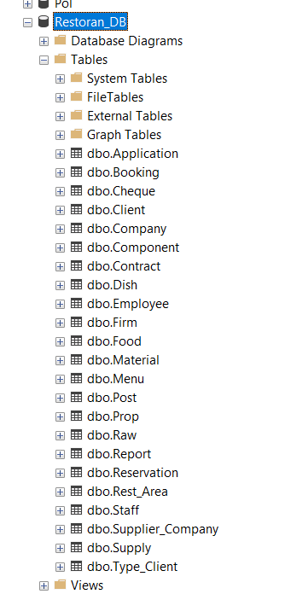

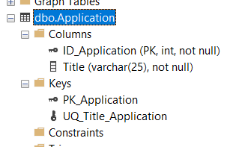

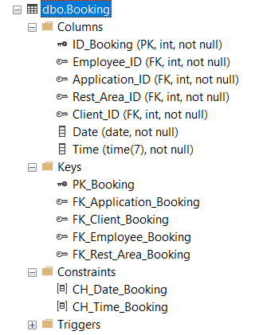

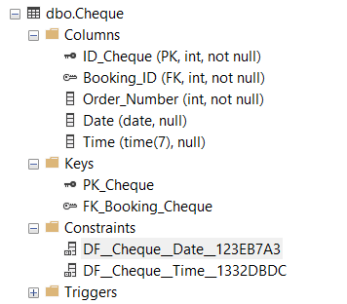

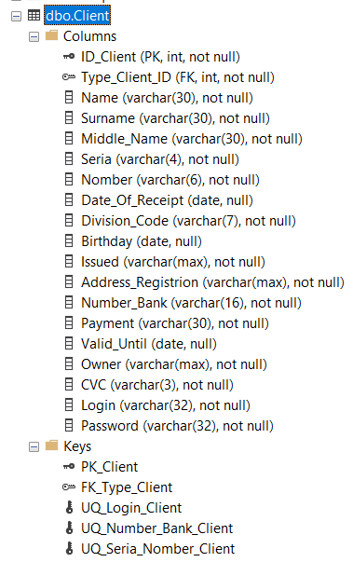

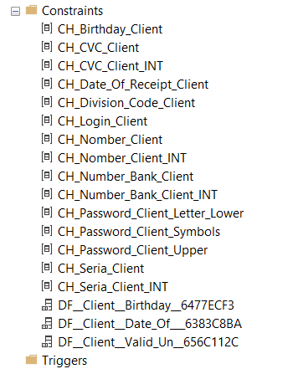

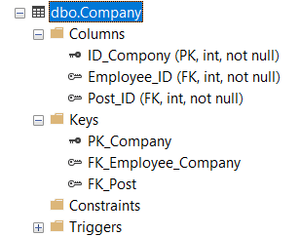

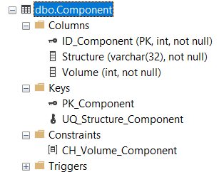

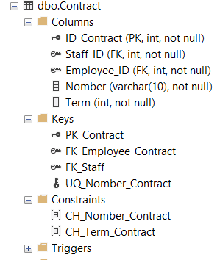

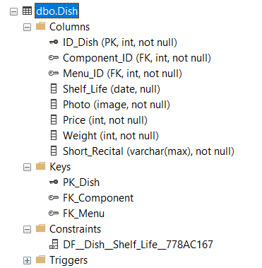

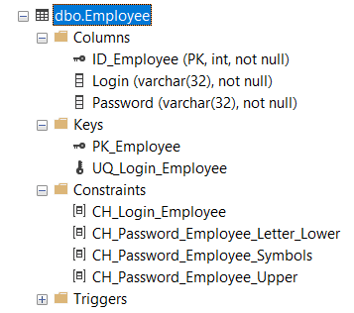

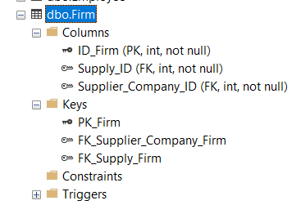

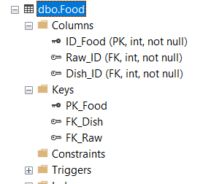

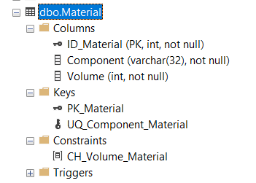

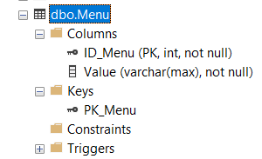

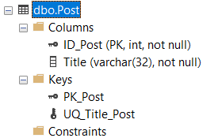

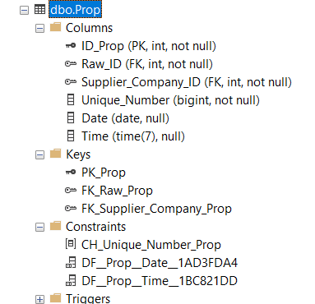

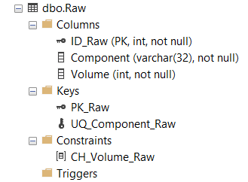

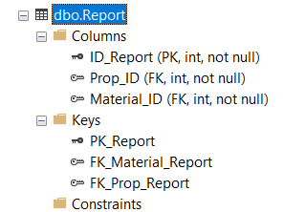

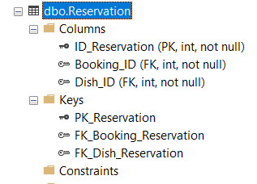

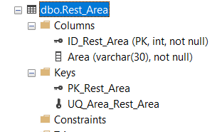

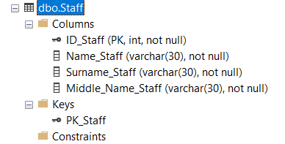

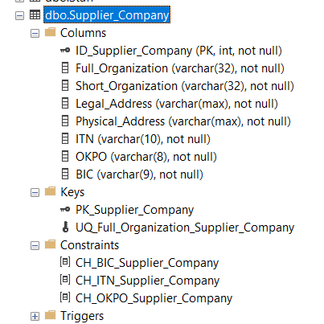

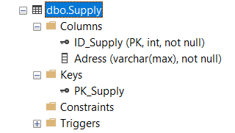

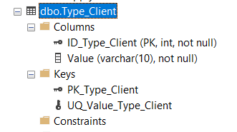

1. Продемонстрировать даталогическую модель данных, из инструментальной среды разработки баз данных

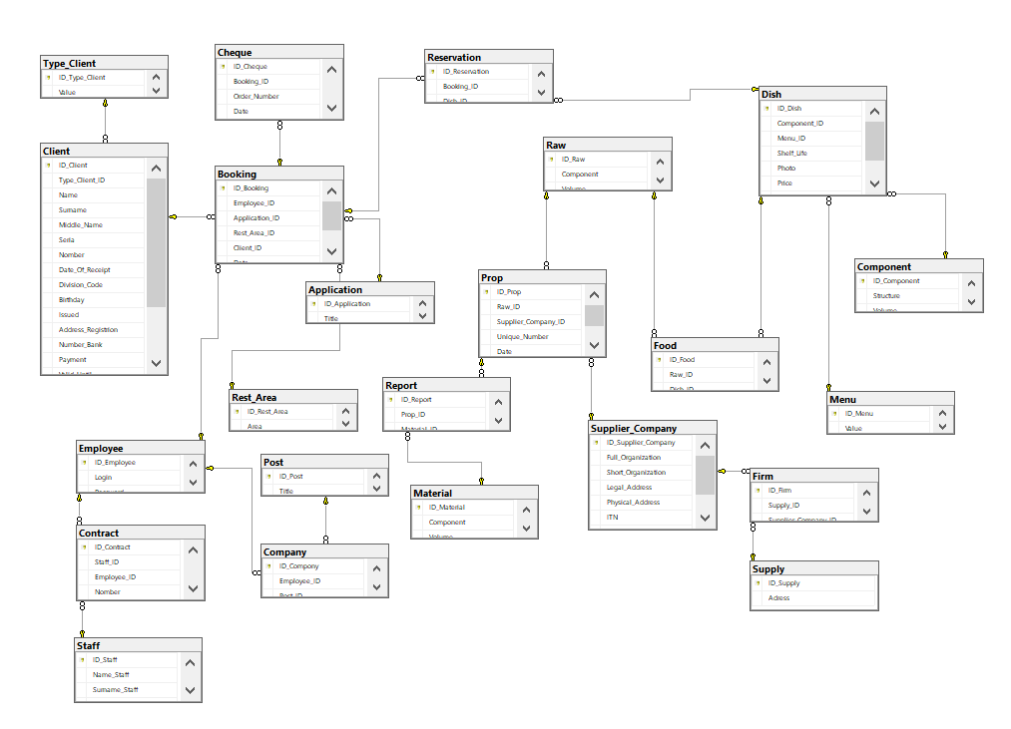

1. ВЫВОД

Я получил навыки, на основании проведённого анализа предметной области, а именно в проведении нормализации, приведение ненормализованной формы к 3НФ, применение свойств данных, которые подлежат хранению в базе данных к нормализации отношений, приведении отношений к структурированному виду, применение принципов и механизмов межтабличных связей.

1. СПИСОК ИСПОЛЬЗУЕМЫХ МАТЕРИАЛОВ

Пример этапов практической (Word, [задание](https://drive.google.com/file/d/1zYxKsKm5Ab-BnWJW_s2Mf3UT1uGUmMb6/view?usp=drive_web&authuser=1), [шаблон отчёта](https://drive.google.com/file/d/1Kc04FsjOh3HGFh_ZDjBzIs9-qh3YjYNP/view?usp=drive_web&authuser=1).